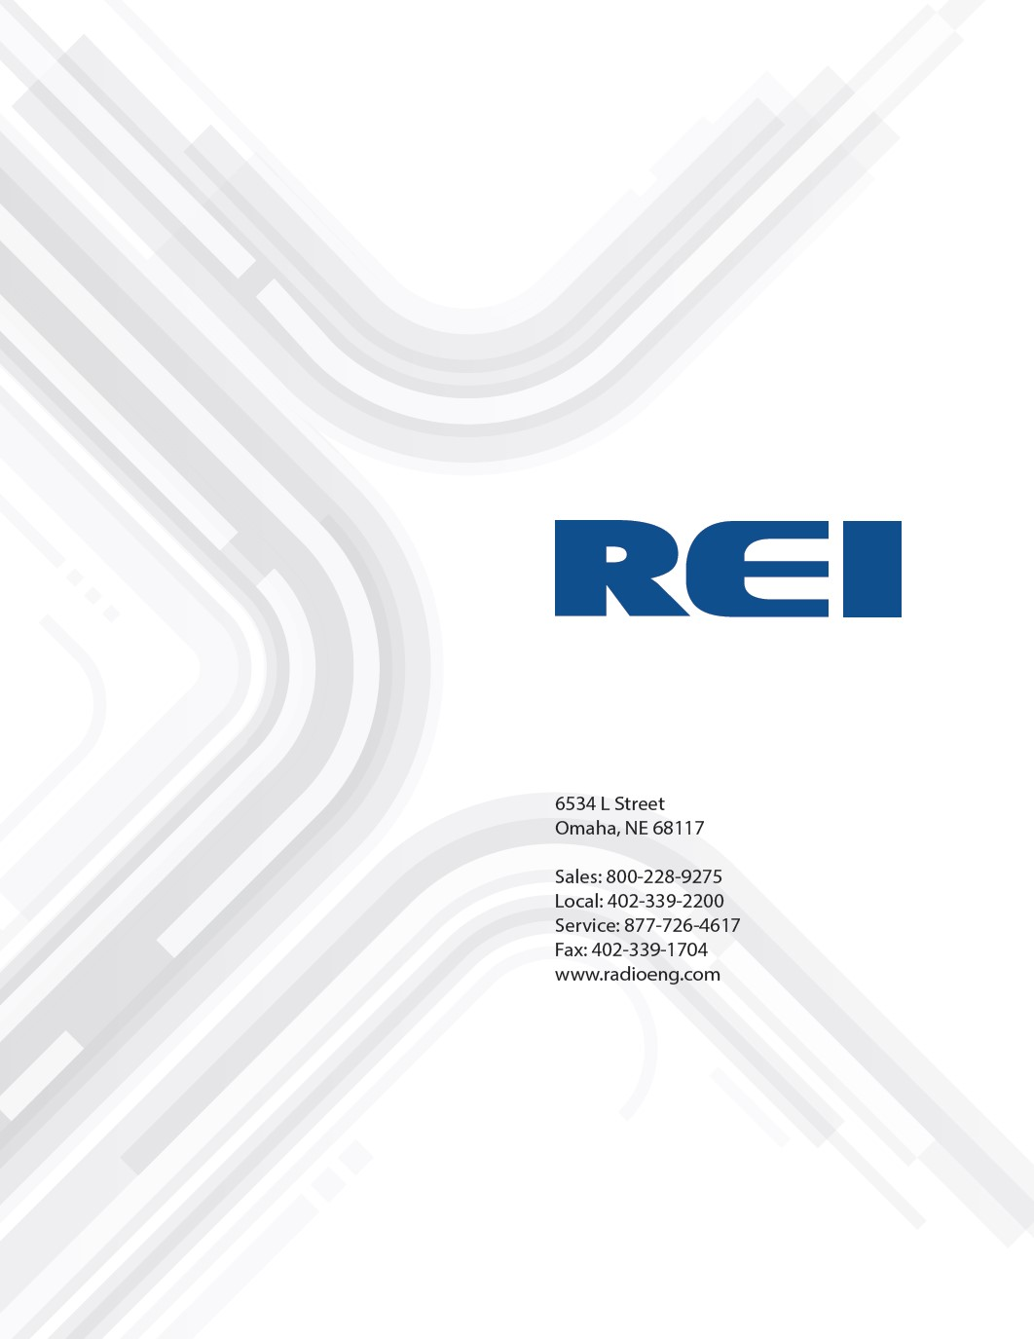
SD-300 Installation Quick Guide
***For Trained and Authorized Technicians Only***

© 2018 Radio Engineering Industries, Inc.

Table of Contents
Contents
1 Introduction and Preparation 3
2 Connecting DVR to Power 4
3 Connecting Cameras to the DVR 5
4 Connect Phone to SD-300 Utilizing REI DVR Toolkit Mobile Phone App 6
5 Android™/iPhone™ Instructions 7
5.1 REI Toolkit Dongle Connection 7
5.2 Android™ Connection 8
5.3 iPhone™ Connection 8
5.4 Auto Local/Manual Remote 8
5.5 Logging In 9
6 Configuring SD-300 System for Use 10
7 Live Viewing for Sensor Test and Camera Aiming 11
8 SD Card Function 12
9 Support 12

Introduction and Preparation

This document will give you a high-level overview on how to install and set up the SD-300 Camera System by an authorized installer.
- Review your parts to ensure you have all parts needed before proceeding with an install.
- Refer to the SD-300 System Diagram provided if unsure of the parts needed.
- Download the REI DVR Toolkit from the Apple App Store or from the Android Play Store for easy access to the SD-300 DVR

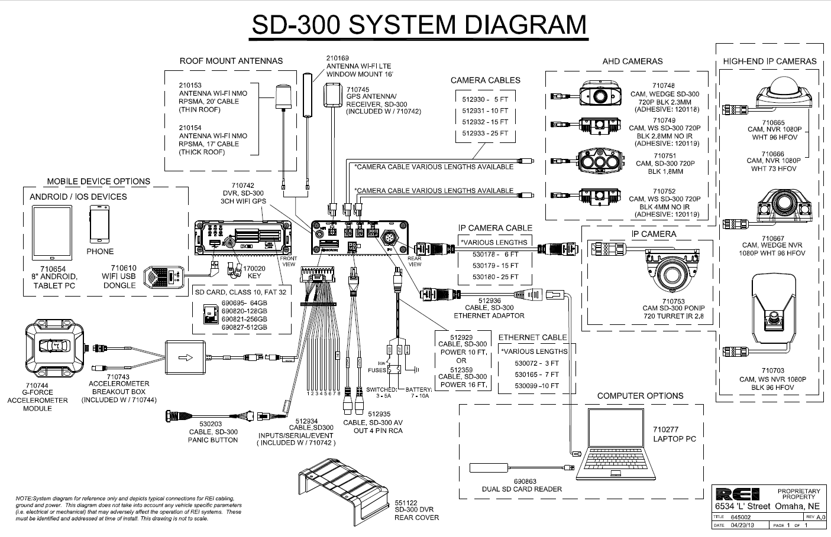

Connecting DVR to Power

- Start by choosing your installation location in the vehicle. (The most common place for the SD-300 DVR is behind the glove compartment / under the dash)

- You will connect 3 wires to power the SD-300. The leads will be labeled on the SD-300 Power Cable (512929) with Ground, Battery, and Switched. The Ground should be connected to a ground point on the vehicle, the Battery lead will be connected directly to the power source or battery with a 10amp fuse inline between the DVR and the battery. The Switched lead should be connected to the ignition power with a 5amp fuse inline between the ignition power and the DVR.
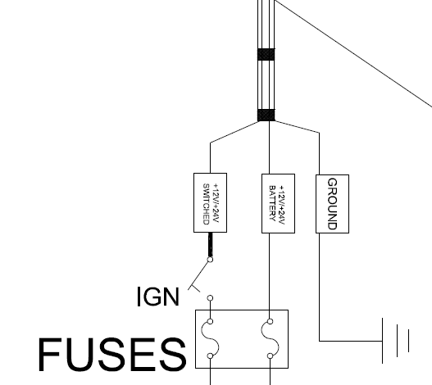
- When the DVR is fully powered the blue power light will be on and turn solid blue

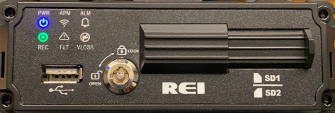

Connecting Cameras to the DVR

- Determine the best location for the camera, keeping in mind the following guidelines:
- Recommended area is the center 1/3 of the windshield, as high as possible.
- Avoid any areas that have tint on them.
- Mounting location in the path of wipers is recommended.
- Prepare surface for camera:
- Thoroughly clean surface area where camera is to be installed. Use provided alcohol pad as final cleansing to remove any dirt, grease, and smudges.
- Mount camera to windshield:
  - Peel protective film off of adhesive pad.
  - Remove lens cap from camera.
  - Carefully clean lens surface with clean soft cloth if it's dirty.
  - Carefully position camera vertically (cable pointing to the top). Apply moderate pressure to camera onto windshield for 5-10 seconds to allow adhesive to fully engage.
- Connect camera cable:
  - Connect camera to DVR utilizing cable 512931.
  - Use weather-proof gland if needed when connecting the camera to the cable
5. Configure the camera (if needed):
- Refer to REI document 640521 found at our customer support website:
www.radioeng.info under the category hardware manuals to configure the camera.

6. Adjust camera angle (if needed):
- Loosen screw on camera neck (utilizing the tool included in the camera packaging).
- Adjust camera to desired angle.
- Tighten screw on camera neck.

Connect Phone to SD-300 Utilizing REI DVR Toolkit Mobile Phone App
The REI DVR Toolkit must be downloaded on the handheld device used in conjunction with the REI Toolkit Dongle and the DVR.
To download the REI DVR Toolkit, complete the following instructions:
If using an Android ™ device:
- From the Google Play Store search for the REI DVR Toolkit by typing REI DVR Toolkit in the Search window in the Apps section and click the Search icon.
- Click on the REI DVR Toolkit icon to open the app
- Click the Install button
If using an Apple device (iPhone ™):
- Enter REI DVR Toolkit in the search window on the Apple application store and click search
- Click Get
- Click Install
- Sign In with your Apple ID and follow the installation prompts

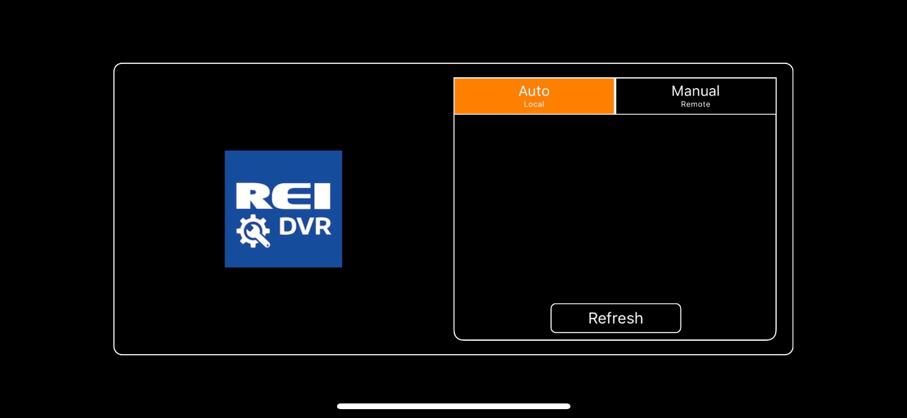

Android™/iPhone™ Instructions

The connectivity using an Android™ device and an iPhone™ is very similar.

REI Toolkit Dongle Connection
Before establishing connectivity with your Android™ or iPhone™, plug the USB cable from the REI Toolkit Dongle into the DVR.
When the REI Toolkit Dongle is connected to the DVR, a blue ‘Power’ lamp will illuminate to indicate the device is operating.
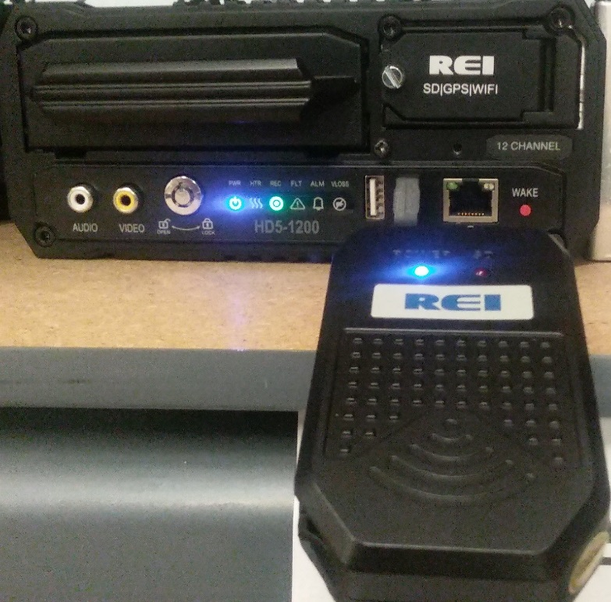
REI Toolkit Dongle connected to a DVR and operational
Note: If the REI Toolkit Dongle is unavailable it is possible, with REI’s SD-300 DVRs to obtain a Wi-Fi connection by removing power and restarting the SD-300. An access point (AP) mode with the same vehicle name as the DVR will pop up for 3 minutes. After 3 minutes the AP Mode will shut off if there is no connection made.

Android™ Connection

To connect to the REI Dongle, go into ‘Settings’ and choose ‘Network & Internet,’ and then ‘Wi-Fi.’
From the list of Wi-Fi links, locate the appropriate Wi-Fi link and attempt to make a Wi-Fi connection. It is normal to see the message ‘Connected, no Internet’ indicating there is no Internet connection. Close the application.
From the home screen of your Android™ device, select the REI DVR Toolkit icon that will open the initial REI DVR window.

iPhone™ Connection

When using an iPhone™, make sure the device is plugged in the DVR (for example REI-009). To verify the Wi-Fi connection to the DVR is available on your iPhone™, select the Settings icon and then select the Wi-Fi icon to open the list of available Wi-Fi networks under ‘CHOOSE A NETWORK’. At this point, the connection for the example DVR, REI-009, should appear on the list of Wi-Fi networks. From the home screen of your iPhone™ select the REI DVR Toolkit icon to open the REI DVR window. Once the REI DVR Toolkit has been opened, the initial REI DVR window will appear on the iPhone™ with the name of the DVR connection (the example REI-009 shown on the Initial DVR window). At this point, the REI DVR Toolkit is available for use.

Auto Local/Manual Remote
On the initial screen, Auto Local is selected by default. This setting means the DVR wireless hardware switched over to access point mode and is connecting locally on the bus. If set to Manual Remote, the access point is based on IP forwarding to connect to lot-based Wi-Fi to enable a connection to any of the active buses remotely without having to actually be aboard the bus.
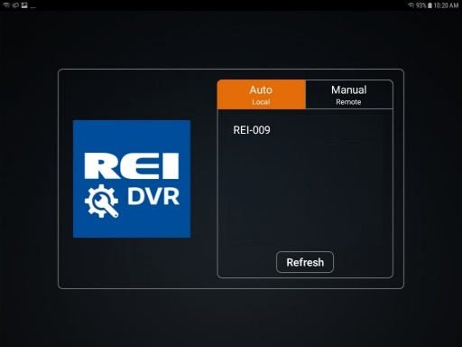
Initial DVR Window

Logging In

Touch the name of the DVR, (REI-009 for example) and a Login prompt will appear as shown below.

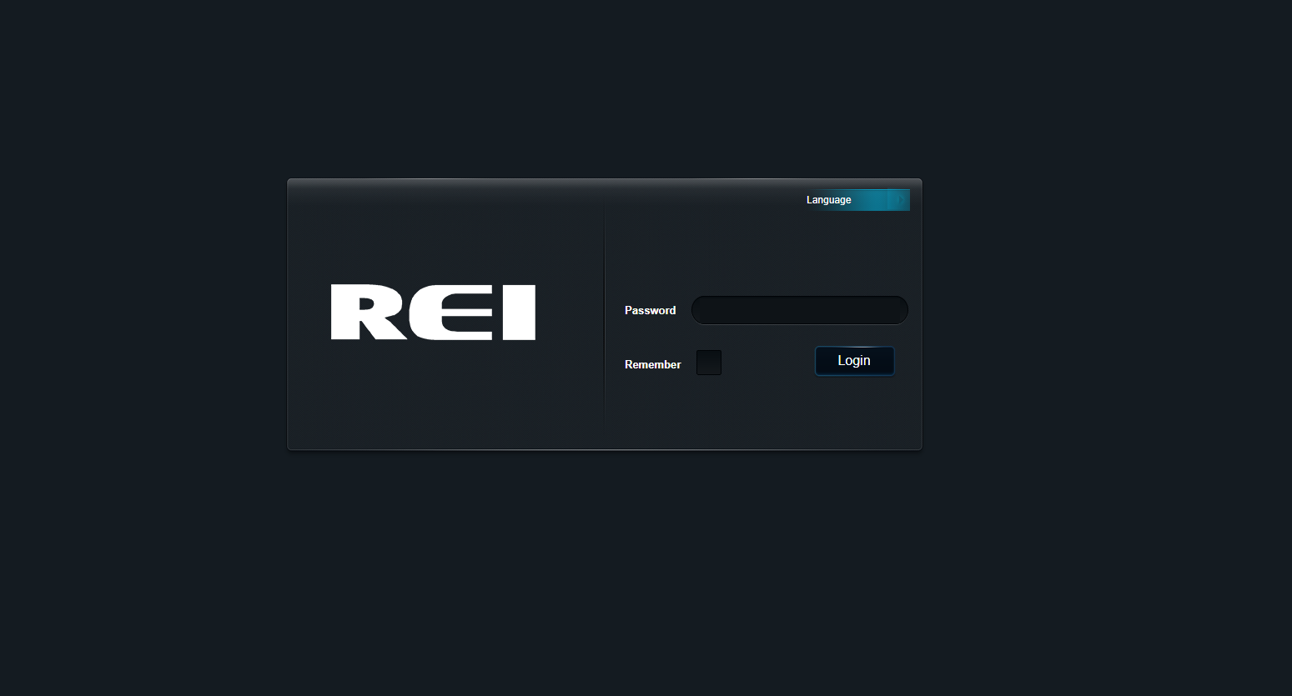
Login Window
By default, the installer password is installer. The Remember box may already be checked. If not, enter the password and click Login.

The firmware can be utilized in the same manner as it is from a typical PC terminal. For additional information refer to the Menu Configuration section of the SD-300 Series Mobile Digital Video Recorders manual (640515 Rev B) at http://www.radioeng.info/series_sd.html

The list of System, Video, Input Setup, and Network buttons on the left side of the window can be scrolled up and down as needed on either the Android or iPhone by dragging a finger over the list.

Configuring SD-300 System for Use

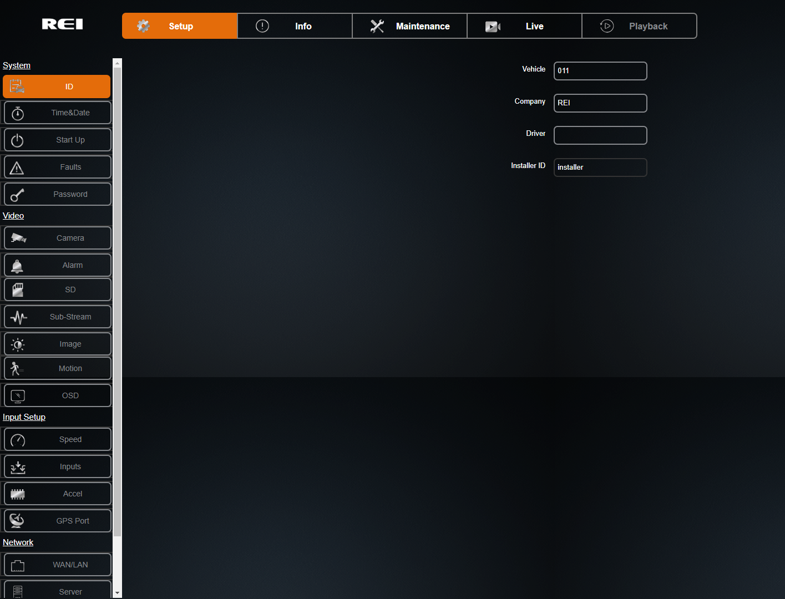

- Go to the Setup tab on the top menu and the ID tab on the left menu. Enter the vehicle identification (ex. … VIN, Cab Number, Car Number), the company that owns the vehicle, Car Owner or Driver and then click on ID again to save the information.
- Next go to the Maintenance tab on the top menu and the Config tab on the left menu. Click on Choose File and select your Installer Configuration file to upload. Your file could be on your laptop, or on a USB memory stick, or on an SD Card in the Wifi dongle (see section 8).
- Once you have selected the file, click import. To verify that the configuration installed go back to the Setup top tab and ID left tab and your personal install ID should be listed in the Install field.
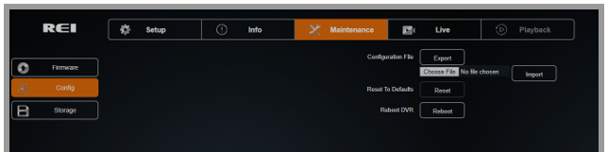

Live Viewing for Sensor Test and Camera Aiming

- Click on the Live 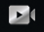 tab on the top menu. Here you should be able to view a live feed of your camera(s) and use this menu to point (aim) the cameras and capture the optimal view (refer to 3.6). To exit Live view, click on the icon and it will take you back to the main menu.
- Click on the icon while in Live viewing to see DVR details along with Sensor status

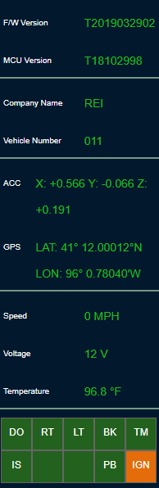

SD Card Function

On the side of the REI Toolkit Dongle is a slot that serves as a Secure Digital (SD) card reader.
When the red SD lamp is active, it indicates a SD card is successfully loaded in the SD card slot and operational.
The primary purpose of using the SD card function is system upgrades. A system upgrade can be performed by downloading the upgrade content from the SD card to the DVR. The card operates similar to a flash drive, and the system-upgrade content from the SD card can be displayed on your handheld device and the system upgrade steps can be performed.

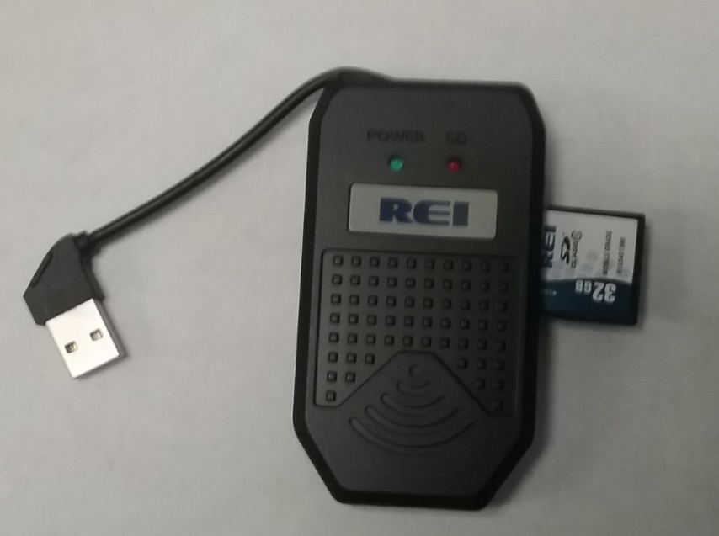
REI Toolkit Dongle accompanied with a SD Card

Support
If at any time you run into issues with any aspect of REI Software Suite, or with the DVRs, feel free to contact the REI world‐class team of technical support specialists. They are available 24/7 to assist you.
Service Hotline: 1‐877‐726‐4617 (Toll Free).

